=> Main goal is to reconstruct signal

**1) PCF8591 ADC-DAC module with I2C interface:**

**https://moodle.clarkson.edu/pluginfile.php/165307/mod_label/intro/PCF8591.pdf**

* Max sampling frequency locked at 11.1Khz
* I2C Max bus speed locked at 100Khz
* Custom I2C address is “1001”&”A2”&”A1”&”A0”
  + On this chip, ALL A2,1,0 set to 0 => Address = 1001000
* Input is an analog signal(created with a DC offset with a 3.3 ppk)
  + Output is a digital signal

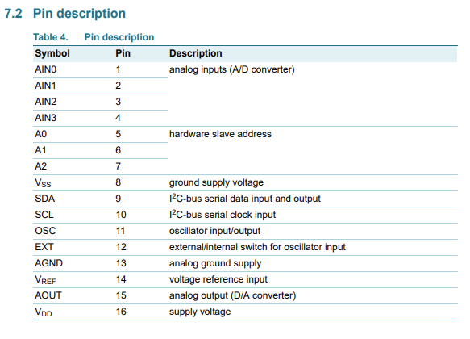

2) LCD

* Default Address of I2C is 0100111
* Set to 4 bit to accommodate for I2C’s 8bit data MAX per transaction
  + Sends D7 to D4 first then D3 to D0

3) PWM

* Read 8 bit value from the I2C
* PWM signal is proportional to 8 bit value of the data
* Choose between 4 inputs to determine the pwm using the button
* AIN2 goes through the LPF to oscilloscope

4) Board DataSheet + GPIO

<https://www.mouser.com/pdfDocs/TRM-TE0726-03.pdf>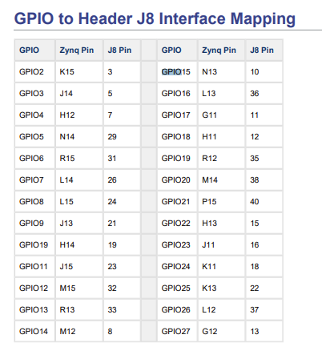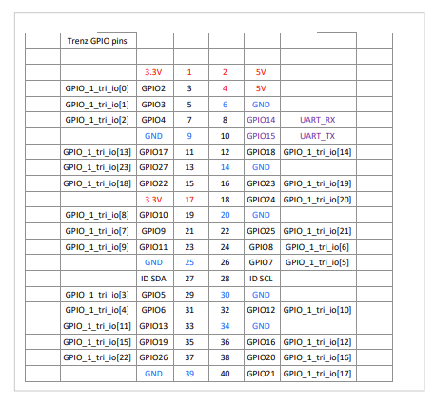

5) Clock Generation

* Clock output
* Frequency varies between 500 and 1500 hz
  + Changes based on the ADR values
* Enable or disabled based on btn1 press